Advancing care, advocacy and research in support of those living with motor neurone disease (MND)

Pre-Budget Submission 2022-2023
September 2022

MND Australia
PO Box 117, Deakin West, ACT, 2600
T: 02 8287 4980
ABN: 52 650 269 176
www.mndaustralia.org.au
info@mndaustralia.org.au

Submitted by: David Ali, CEO
T: 0438 202 642
davida@mndaustralia.org.au

Executive Summary
MND Australia seeks a commitment from the Federal Government to fund in the October 2022 mid-Budget the following three initiatives to improve the lives of all Australians impacted by motor neurone disease (MND):
- Improve equity of access to needs-based person-centred in-home supports for older Australians with MND
Fund and implement improvements to the in-home Aged Care system to provide funding and support to meet assessed needs for people with MND irrespective of age.

- Improve equity of access to assistive technology for older Australians with MND
Fund MND Associations to provide a national assistive technology (AT) program to ensure there are no costs and minimal waiting times for AT that people with MND need to acquire as their disease progresses.

- Improve equity of access to genetic services for Australians with MND
Ensure access to Medicare funded genetic services for Australians impacted by MND.

About MND
Motor neurone disease (MND) is the name given to a group of neurological diseases in which motor neurons – the nerve cells that control the movement of voluntary muscles – progressively weaken and die. With no nerves to activate them, people with MND lose their ability to walk, to speak, to swallow and to breathe.

MND affects each person differently with respect to initial symptoms, rate and pattern of progression and survival time. Average life expectancy is just 27 months from diagnosis, with a third of people dying within one year and more than half within two years of diagnosis.

There are no known causes for MND, apart from the 10 per cent of cases which have a genetic basis. There are no effective treatments and there is no cure. There are no remissions and progression of MND is usually rapid and relentless creating high levels of disability and a consequent need for a wide range of changing supports based on the person’s complex needs.

The MND Australia Deloitte Access Economics Report found that in Australia the per-person cost of MND in 2015 was $1.1 million ($1.22m in 2022 dollars based on–RBA calculation for inflation increase 2015 to year ending 2021), dwarfing the cost of many other chronic health conditions. The report states that the total cost of MND in Australia in 2015 was $2.37 billion ($2.63b in 2022 dollars), comprising $430.9 million ($477.9m) in economic costs and $1.94 billion ($2.11b) in burden of disease costs. The enormity of the cost is akin to the brutality of MND.

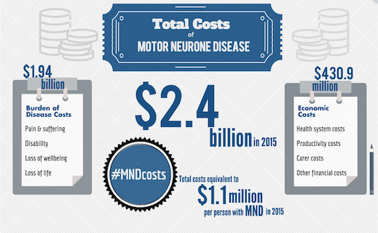

Whilst there are currently no effective treatments, there are a range of measures that are vital for people living with MND and that improve the quality of life of people living with MND and reduce the cost of this condition on the community. These include:
- timely and expert diagnosis
- early and evidence-based interventions from specialist MND multidisciplinary teams, local services and MND Associations
- access to person centred, needs based in-home care, assistive technology and specialist palliative care which play vital roles in maintaining quality of life, social engagement and independence
- specialist planning and assessment and coordination of care, including responding to and forecasting needs, before they become urgent

These supports and interventions are crucial in helping people to plan ahead to prevent crisis and avoidable hospital and residential aged care admissions. They are also crucial in strengthening the informal supports available to the person, including supporting the primary carer to maintain their own health and wellbeing and their caring role.

Just over half of the estimated 2,100 Australians living with MND at any one time are diagnosed when aged 65 or older and unable to access supports to meet their individual needs through the National Disability Insurance Scheme (NDIS). They must rely on the aged care system which, unlike the NDIS, is capped, means tested and designed to address ageing, not disability. Increasing inequity, inadequate funding for services to meet assessed needs and long waiting times are causing many older people with MND to be pushed into financial hardship or residential aged care earlier than they wish or need.

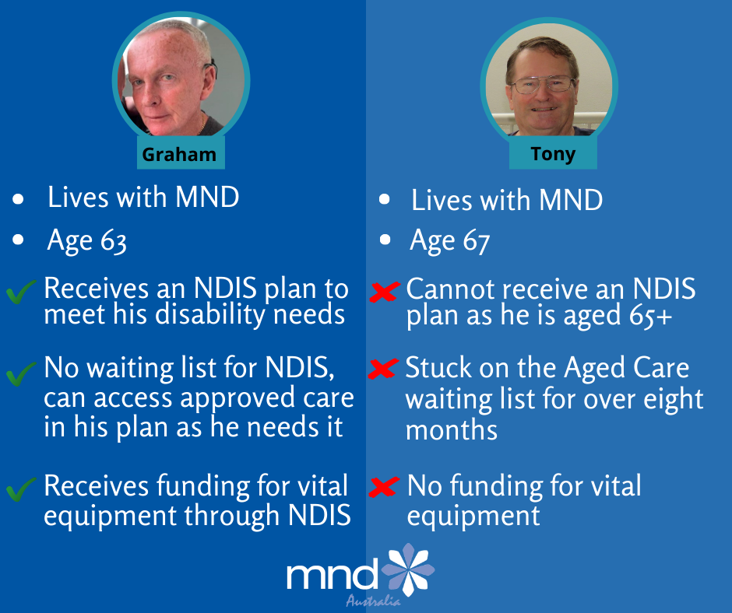

This real life case study of two men in very similar circumstances starkly highlights the inequity of access to supports for people diagnosed with MND in Australia.

Graham has a NDIS plan in place to fund reasonable and necessary supports, including high cost vital equipment, with no waiting period to access these supports. Graham is now aged 65 but as he has a NDIS plan in place he can continue to access NDIS funded in home supports to meet his changing needs as MND progresses. Crucially he has been able to remain at home.

Tony was assessed as eligible for a Level 4 Home Care Package (HCP). This package of supports is capped at $53,268 per annum with no specific funding for high cost vital equipment. A Level 4 HCP allows for approximately 16 hours of in home care per week NB the Deloitte Report highlights that people with MND require an average of 8 hours support a day. A level 4 HCP was not available following his assessment. Tony waited over 8 months for a HCP to become available. Meanwhile his condition continued to progress and he was forced to move to a residential aged care facility and be separated from his wife. Tony was fortunate to be accepted into a RACF near his home. Many people are forced to accept places far from home as many RACF will not accept people living with MND due to the complexity of their needs.

About MND Australia
MND Australia is the national peak body of state organisations that support those living with and impacted by motor neurone disease (MND). Since 1983, we have been the voice for the MND community. Our national and international networks help increase understanding of the disease and advocate for the needs of those affected.

The six state MND associations provide direct support and services to people living with MND, their carers and families and the health professionals and service providers involved in their care in all states and territories.

Together we are committed to ensuring people living with MND, their carers and family have timely access to:
- care and support to meet their individual needs to enable them to live better, for longer, no matter their age or postcode
- diagnosis, clinical trials, technologies and therapies.
MND Australia has been funding world-class MND research to increase understanding of MND for over 30 years. We recognise the urgent need to invest in the research pipeline to uncover the causes of MND and the development of therapies to stop or slow this devastating condition. MND Australia commends the government for their investment in MND research which has been vital to the acceleration in research and understanding of MND. MND Australia urges the Federal Government to similarly invest in care to improve the lives of people living with MND today and the foreseeable future as we await discovery and approval of effective therapies.
Recommended Funding Initiatives

In our 2022/23 Budget submission MND Australia calls on the Government to prioritise the following initiatives to improve the lives of all Australians impacted by motor neurone disease (MND), and which are likely to have significant benefits for people with other diseases and conditions:
- Funding and implementation of improvements to the in-home Aged Care system to provide funding and supports to meet assessed needs for people with MND from December 2022.
- Funding of a national assistive technology (AT) program from December 2022 to ensure there are no costs and minimal waiting times for AT that people with MND aged 65 or older need to acquire as their disease progresses.
- Fully funded genetic services for Australians impacted by MND through the strengthening Medicare Fund to improve access to genetic counselling, diagnostic testing, information and support.

- Improve equity of access: in-home supports comparable to the NDIS for older Australians with MND

There is a complete lack of equity for people with motor neurone disease (MND) and other rapidly progressive neurological disease based on their age at diagnosis. This drives an urgent need to improve equity of access to services and support for older Australians with MND irrespective of age and geographic location.

With a third of people dying within one year and more than half within two years of diagnosis, people with MND do not have time to wait for services and supports.

MND Australia, together with our member State MND Associations, has engaged proactively and successfully with the National Disability Insurance Agency (NDIA) since the introduction of the NDIS to support a rapid response and effective planning processes and plan implementation for people living with MND that takes their progressing and complex needs into account.

In contrast, for the 50-60 per cent of people who are diagnosed with MND when aged 65 or older, the current home based aged care system does not adequately address complex and changing disability needs. Consequently, the health and wellbeing of family carers is negatively impacted and unnecessary or untimely admission to residential aged care occurs.

Currently the maximum funding available through a Home Care Level 4 Package is $53,268.10 per annum. In contrast, a report published by the NDIS, Participants with a neuro-degenerative condition in the NDIS (31 March 2021) reported the average annualised committed supports for the 2020-2021 financial year was $242,000 for participants with MND.

It is a fundamental right, that every person with a disability must have equity of access to services and support to facilitate quality of life, independence, safety and community participation. This is even more critical for people with a life limiting, rapidly progressing, degenerative and complex disability like MND. A diagnosis of MND is devastating for the person with MND and their family no matter the person’s age. A diagnosis of MND results in progressing disability, loss of function and the consequent need to constantly adjust and plan ahead whilst facing an unknown life expectancy. Timely access to packages of care that meet assessed needs is integral to maintaining dignity and independence and supporting a person to remain at home with their family. Senior Australians with MND have the right to access adequate services and supports through the aged care system to ensure they can choose to remain at home with their family.

The National Strategic Action Plan for Rare Diseases outlines action and policy for conditions such as MND to ensure equity of access. The Action Plan is predicated on an integrated, person-centred approach which is responsive to changing needs.

It is time to end discrimination in accessing supports based on age. Equity of access means ensuring timely, funded and accessible Aged Care services that are needs based and person-centred.

MND Australia welcomes the new Government’s commitment to focus on improvements to the care of people living in residential aged care. We strongly support the proposals to ensure that registered nurses are available on site 24/7 and to increase the minutes of care per day per resident as recommended by the Royal Commission into Aged Care Quality and Safety. It is critical that the small number of people living with MND in residential aged care, many of whom will have complex needs and be at end of life, have access to optimal nursing, palliative and personal care.

Like other senior Australians, most people, living with MND, want to stay at home with access to in-home supports that meet their changing and complex disability needs. MND Australia welcomes the commitment to higher wages for home care workers and the proposal to cap administration and management fees which currently reduce the funds available for vital care and support.

However, a more fundamental reform of Home Care is urgently required.
The Support at Home Program Overview outlines plans to reform in-home aged care services with a focus on the provision of services based on the assessed aged care needs of the client.

MND Australia welcomes the consultations and research currently underway to inform the reform of in-home aged care as outlined on the Department of Health and Aged Care website including the consideration of senior Australians with disabilities who may not be eligible for the NDIS. The age distribution, disease trajectory and NDIS participation of younger people with MND has the potential to inform this process and we look forward to contributing to the consultations and research.

Whilst understanding the need for extensive consultations and research MND Australia is extremely concerned that the timeframe for delivery of a reformed and improved in-home aged care program has been extended to 1 July 2024. Approximately 400 people aged 65 and older will be diagnosed with MND over the next two years, they will not have time to wait for these reforms. Older people currently living with MND, who have not yet received a Home Care Package (HCP), or one at the level they have been assessed as needing, should not have to be forced into a Residential Aged Care Facility due to inadequate support or die waiting for their HCP.

MND Australia calls on the Australian Government to urgently fund and implement interim measures to ensure access to in-home needs based supports for people with rapidly progressing, life limiting conditions such as MND.

These interim measures should include:
- Fast track access to aged care assessment
- Prioritisation for urgent access to the level of HCP the person with MND is assessed as needing
- Expansion of the Commonwealth Home Support Program (CHSP) to provide fast track access to additional supports
- Implementation of the funding model for the provision of AT to people with MND and rapidly progressing neurological conditions as outlined below

MND Australia calls on the Australian Government to fund and implement interim measures to the Aged Care System to support timely access to needs based in- home care for people with MND by July 2023 even as part of a pilot study

- Improve equity of access: Assistive Technology for older Australians with MND

Given the needs of people with MND are complex and can change rapidly, timely access to a range of assistive technologies to support independence, comfort, communication and breathing, as well as the health and wellbeing of their carer, is vital. Unfortunately, funding for and access to assistive technology is not equitable and is discriminatory for people aged 65 and over compared with the NDIS. Older Australians have to trade off the funding for their care needs to fund assistive technology.

MND Australia fully supports implementation of Recommendation 34 of the Royal Commission into Aged Care Quality and Safety to establish an assistive technology and home modifications category within the aged care program from December 2022. However as noted below, the aged care reform has been delayed to implementation from July 2024.

We note the Department of Health and Aged Care Support at Home Program Overview which outlines the plan for the new assessment process to consider a person’s need to access to goods, equipment, assistive technologies (GEAT) and home modifications. Having access to the supports older Australians are assessed as needing for both GEAT and home modifications without having to save funds needed for care is imperative.

MND Australia welcomes the Department’s commitment, as outlined in the overview to undertake co-design activities with stakeholders and to continue developing and refining the approach to providing GEAT and home modifications, including higher cost items. We are grateful that the state MND Associations are represented in the stakeholder consultation.

The Assistive Technology for All (ATFA) Alliance recommends a national aids and equipment program for older Australians that will harmonise existing state and Commonwealth-based AT programs and those operated by not-for-profit organisations. A national assistive technology program must be fully funded and needs based.

For people with MND and other rapidly progressive neurological disease who are excluded from the NDIS it is critical that any program developed provides the timely response that is required.

MND Australia notes with concern that the timeframe for implementation of Aged Care reform has been extended to July 2024. Whilst we acknowledge the need to ensure sufficient time to properly engage with stakeholders and design a suitable model, this delay will negatively impact people living with MND and add to the current long wait times for access to needs based AT and supports.

MND Australia therefore seeks funding to support the state MND Associations to provide vital equipment to older Australians with MND as outlined in the Appendix One. With funding provided in this Federal Budget the state MND Associations would be able to roll out a cost effective and proven solution for AT provision to people living with MND and other rapidly progressive neurological conditions from December 2022.

Federal Government funding to support MND Associations would ensure that older people living with MND are able to access vital equipment as soon as a need arises from December 2022 as recommended by the Royal Commission. This not-for-profit based model of AT provision would also act as a pilot project to inform the design and development of a national program with respect to older Australians living with rapidly progressing neurological conditions.

MND Australia calls on the Australian Government to fund MND Associations to provide a national assistive technology (AT) program to ensure there are no costs and minimal waiting times for AT that older people with MND need to acquire as their disease progresses from December 2022

- Improve equity of access: genetic services for Australians impacted by MND

Equity of access is about ensuring all Australians with MND have fast track access to clinical trials, therapies proven to slow progression and interventions to stop MND.

Currently there are no effective treatments to significantly slow or stop disease progression. The causes of MND also remain unknown except in the approximately 10% of cases where MND is ‘familial’ and the person has an MND-related genetic mutation. The remaining 90 per cent of people with MND are said to have ‘sporadic’ MND. If a person has an MND-related genetic mutation each of their children has a 50/50 chance of inheriting the MND-related genetic mutation. Mutations in the genes that cause MND are also found in some people who have sporadic MND. The number of people with sporadic MND who also have an MND-related gene mutation is not known.

“When a family member is diagnosed with MND it is devastating. It is just like being given a life sentence. Watching that loved one live with MND is one of the most challenging and rewarding experiences you can go through. You support that family member all the way up until the end, creating memories to last a lifetime. Once they have passed, you think you are free from MND. But then you’re told that around 10% of cases are hereditary and that your loved one was one of those 10%”
(Kaitlin and Jessica Ellis, MND Genies: Advocating and raising awareness of MND)

Research is accelerating rapidly, our understanding of MND is increasing and there are a record number of clinical trials underway around the world. More disease causing genetic mutations are being discovered and clinical trials to target specific MND causing genes are emerging. In addition, in families with a known genetic mutation, in-vitro fertilisation (IVF) and predictive reproductive genetic testing provides an option to stop MND in that family. Interest in and access to genetic services as part of diagnostic testing and multidisciplinary care is therefore becoming increasingly critical.
“Knowing you carry a familial MND gene allows you to plan for the future, especially for female members planning for a family. In Vitro Fertilisation (IVF) treatment allows for the familial gene to not be passed onto future generations”. (Kaitlin and Jessica Ellis)

In light of this accelerating area of research the International Alliance of ALS/MND Associations Fundamental Rights of People living with ALS/MND now states that it is a fundamental right to have access, upon diagnosis, to:
- up-to-date education about clinical genetics in ALS/MND
- genetic counselling
- genetic testing
- safeguards against genetic discrimination
- subject to education and counselling, blood relatives should also be given the same access, where relevant.

A recent publication, however, has identified that there are inconsistent approaches to genetic counselling and diagnostic testing for people with MND in Australia. The paper explored client experiences of genetic counselling and diagnostic testing. Three key themes emerged which highlighted the need for:
- information on availability of counselling and testing and access to further information and support
- access to supportive care throughout the genetic counselling and testing process
- understanding of the unique circumstances that inform an individual’s approach toward genetic counselling, testing, results and managing knowledge within the family.

This research highlights the complex nature of genetic testing for people living with MND and their families. Access to genetic counselling and testing, as part of a MND multidisciplinary service, is critical to ensure a supportive and informed approach.

“For us, going through genetic testing right after our mum was diagnosed was a devastating process and we had no continual support. Everyone just believed us when we said we were fine, but in hindsight, we weren’t. We ignored the fact that we had the gene for 2 years and when our mum passed, the realisation that we had a gene for MND came crashing down on us”.
(Kaitlin and Jessica Ellis)

MND Australia welcomes the new Government’s commitment to strengthen Medicare. We urge the Government to ensure the Strengthening Medicare Fund recognises the accelerating area of genomics research to ensure investment and care pathways to improve access to genetic services, information and support.

MND Australia calls on the Australian Government to strengthen Medicare to ensure access to fully funded genetic services for Australians impacted by MND

APPENDIX ONE

Not for Profit Model of Assistive Technology Provision for Older Australians with MND and other Rapidly Progressing Neurological Conditions

The often rapid rate of progression of MND requires ‘fast track’ access to a wide range of Assistive Technology (AT) as soon as a need arises. An AT item may only be required for a short period of time making purchasing items a costly and time consuming exercise, leading to higher waste disposal and poor or no referral systems when the equipment is either scrapped or on-sold.

For people living with MND, the full range of assistive technology may include aids and equipment to support comfort, communication, independence and daily living and non-invasive ventilation to support breathing, quality and length of life. Non-invasive ventilation improves survival by 13 months on average.

MND Associations are currently providing a cost-effective national solution for people living with rapidly progressive neurological conditions such as MND under the NDIS that could be rolled out immediately with a relatively modest investment from the Australian Government.

Where available and appropriate, a person’s NDIS plan will include funding for an annual payment – currently $7,500 to $7,900 per annum – to enable fast track access to a ‘bundle’ of assistive technology from the MND associations. Alternatively, funds are provided to rent individual items from the MND associations when needed. These models work well for people with progressing neurological conditions like MND who have rapidly changing needs. These models have also proven to be cost effective for the NDIA.

Importantly the NDIS provides additional funding for reasonable and necessary home modifications as well as the purchase of specialised and individualised AT items.

In the NDIS report as at 31 March 2021 capital costs, typically AT and home modifications, comprise 12 per cent of annualised committed supports for people with MND. This equates to approximately $25k annually for each person with MND to cover the cost of AT rental or bundles, as outlined above, purchase of specialised and individualised AT and home modifications.

Compared to the average equipment costs of $31,598 ($35,046 in 2022 dollars) per person identified by the 2015 Deloitte Access Economics Report¹ (based on costs pre full roll out of the NDIS) this represents a cost-effective model of assistive technology provision to older people living with MND in Australia.

MND Australia has recently reviewed the number of people registered with MND associations receiving or waiting to receive assistive technology. Based on these numbers, we estimate that nationally there would be up to 450 people with MND aged 65 and older in need of assistive technology comparable to the NDIS at any given time.

Budget to cover MND Association AT bundles or rental over four years:

Year 1 250 people $1,875,000
Year 2 300 people $2,250,000
Year 3 400 people $3,000,000
Year 4 450 people $3,375,000

TOTAL $10,500,000

Budget to cover AT and home modifications comparable to the NDIS (including AT bundles or rental) over four years @$25k per person:

Year 1 250 people $6,250,000
Year 2 300 people $7,500,000
Year 3 400 people $10,000,000
Year 4 450 people $11,250,000

TOTAL $35,000,000

Deloitte Access Economics, 2015, Economic Analysis of motor neurone disease in Australia, report for Motor Neurone Disease Australia
My Aged Care
National Disability Insurance Scheme, Participants with a neurodegenerative condition in the NDIS, 31 March 2021
Convention on the Rights of Persons with Disabilities, United Nations, articles 25 and 26
International Alliance of ALS/MND Associations Fundamental Rights of People Living with ALS/MND, April 2021
National Strategic Action Plan for Rare Diseases, February 2020
Support at Home Program Overview, Australian Government Department of Health, January 2022
Support at Home Program Overview, Australian Government Department of Health, January 2022
Assistive Technology for All, Briefing Paper, Improving access to assistive technology for people with disability who are excluded from the NDIS, 2021
MND Australia 2022 Election Commitments, May 2022
MND Australia Fact Sheet: Familial MND and genetic testing
Miller, T. et al (2020). Phase 1–2 trial of antisense oligonucleotide Tofersen for SOD1 ALS. The New England Journal of Medicine, 383(2), 109– 119. https://doi.org/10.1056/NEJMoa2003715
Crook, A., Jacobs, C., Newton-John, T., & McEwen, A. (2022). Genetic counseling and diagnostic genetic testing for familial amyotrophic lateral sclerosis and/or frontotemporal dementia: A qualitative study of client experiences. Journal of Genetic Counseling, 00, 1– 13. https://doi.org/10.1002/jgc4.1591
Berlowitz et al, 2016, Identifying who will benefit from non-invasive ventilation in amyotrophic lateral sclerosis/motor neurone disease in a clinical cohort, J Neurol Neurosurg Psychiatry, 2016 Mar; 87(3): 280-6.
Birks, O’Mara and Millington, 2020, How a cost effective approach to assistive technology could help the Australian aged care system and older people living with MND, The Mandarin, 2020, Jan
National Disability Insurance Scheme, Participants with a neurodegenerative condition in the NDIS, 31 March 2021

